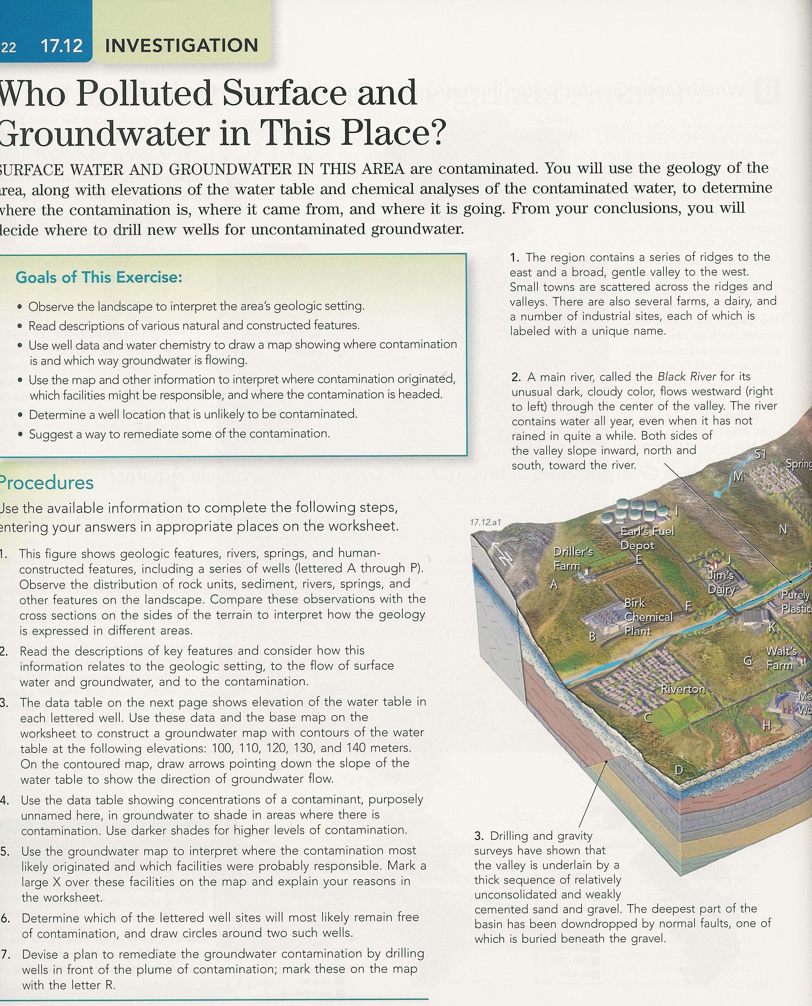
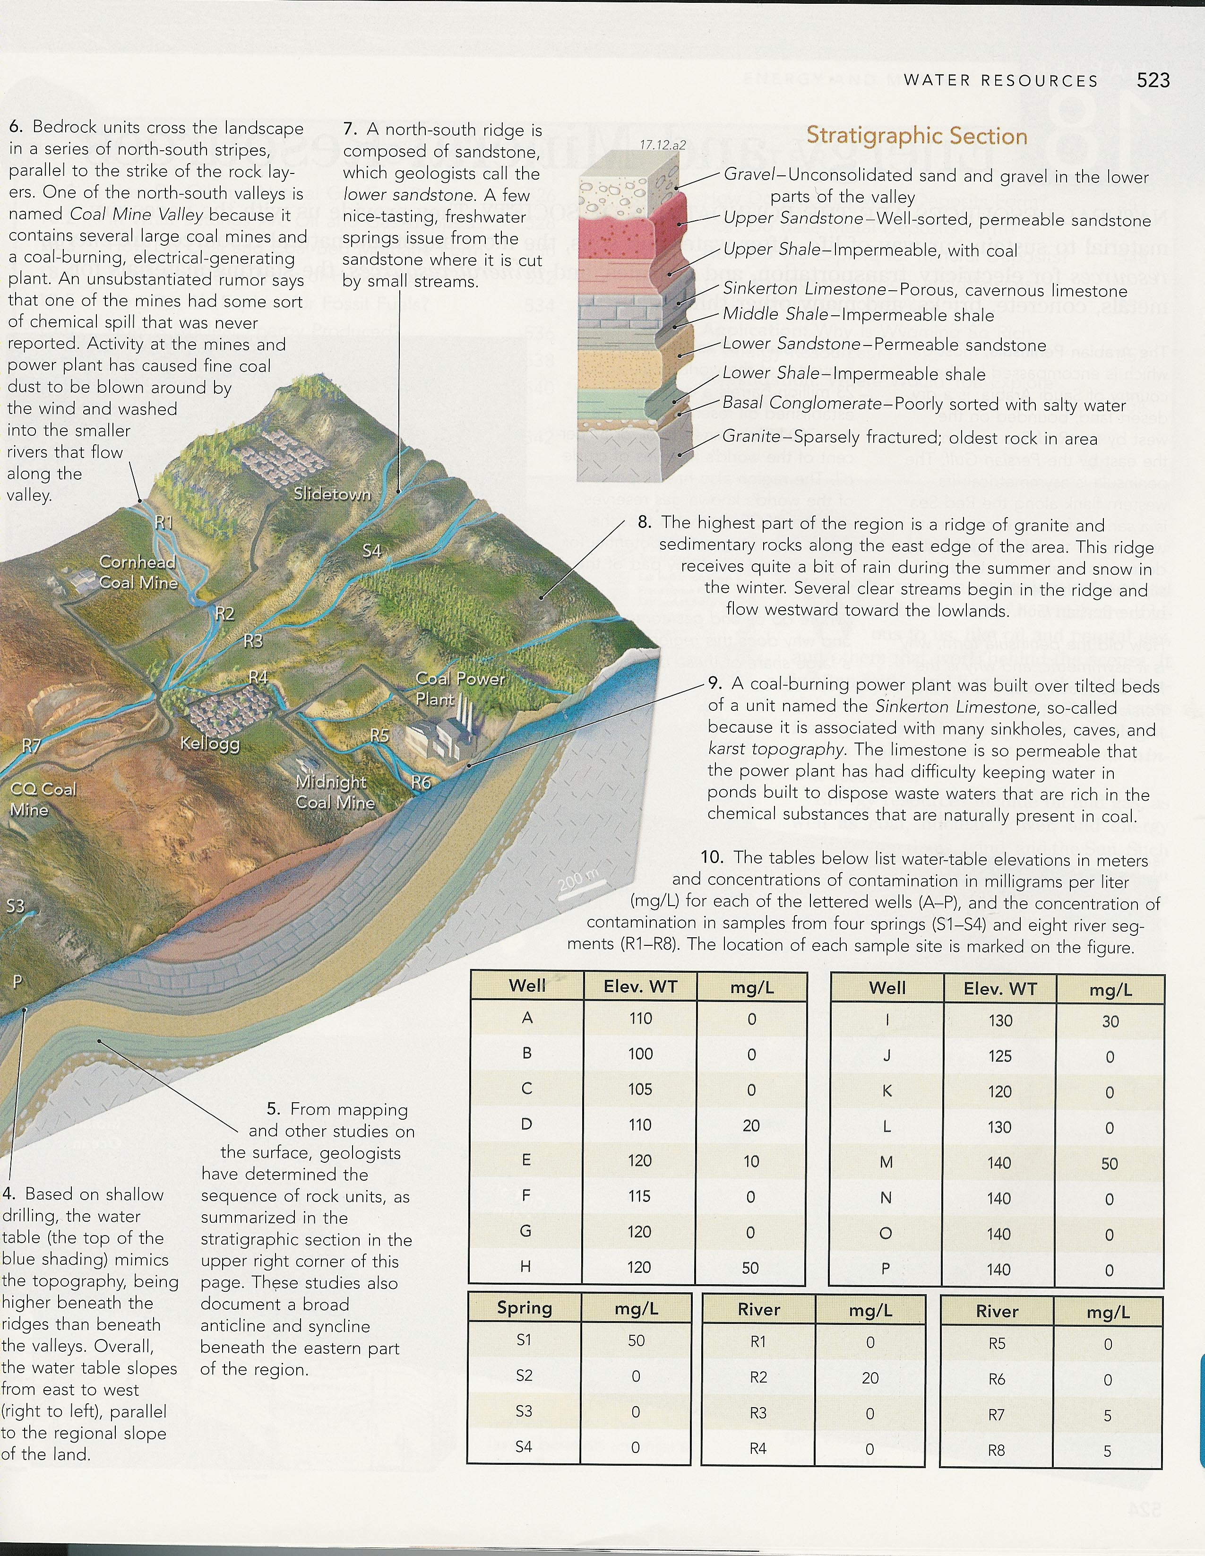
To complete this worksheet, see the instructions in the textbook (Chapter 17 Investigation).

Table 1: Location Map
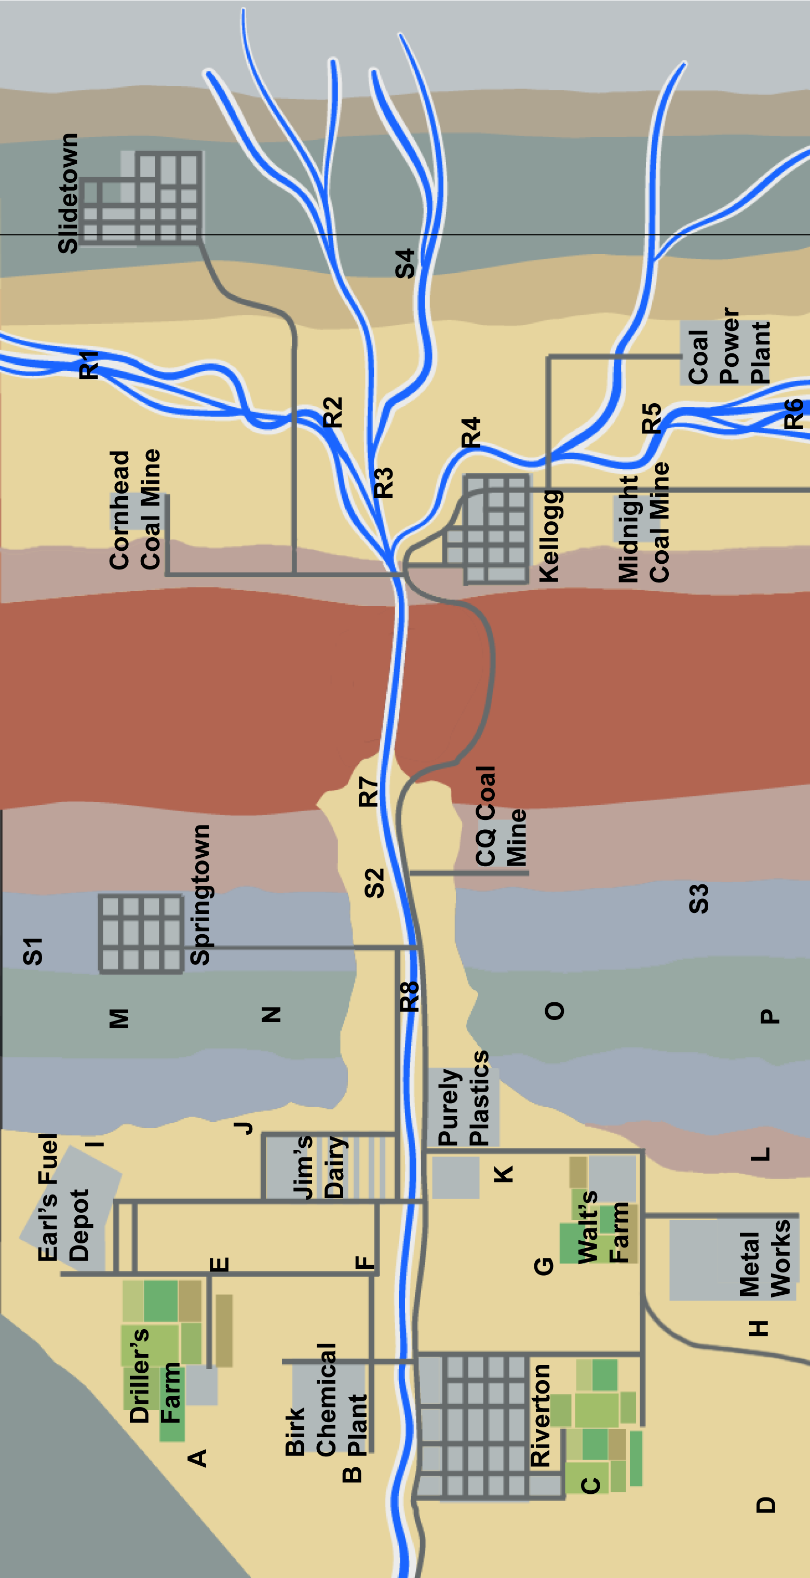 | This map has locations of wells (lettered A to P), samples of river water (labeled R1 to R8), and samples of springs (labeled S1 to S4). Various farms, factories, mines, and other facilities are also shown. Only the roads and outlines of the facilities are shown, not the actual buildings and other details. Colors (or shades of gray) on the worksheet represent in a general way the types of rocks and sediment exposed on the surface; check the cross section in the textbook for details. Draw on this map the following: (1) contours of water-table elevations and draw large arrows showing the direction of groundwater flow; (2) a separate set of contours for concentrations of contamination and use the two sets of contours to determine which facilities caused the contamination; (3) a large X next to the facilities; (4) circles around two wells that you predict will remain free of contamination; and (5) the location of wells you propose to drill to intercept the contamination. Reference the textbook for additional information.
Table 2. Elevations of the Water Table and Concentrations of Contamination
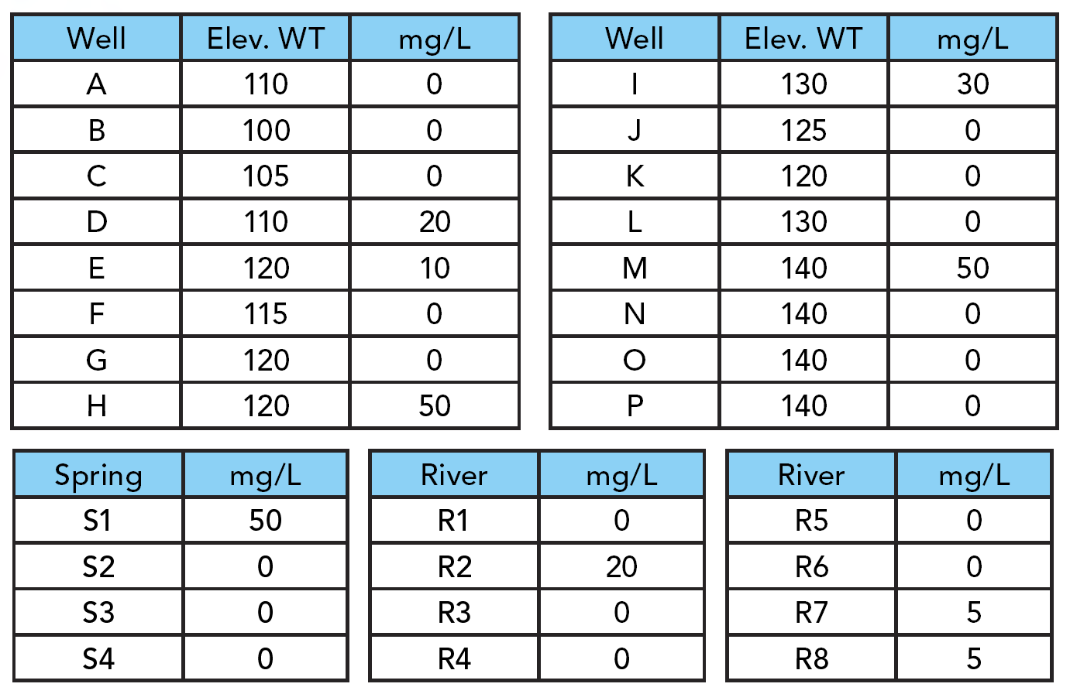
This table shows water-table elevations in meters and concentrations of contamination in milligrams per liter (mg/L) for each of the lettered wells, and the concentration of contamination in samples from four springs and eight river segments. The location of each sample site is marked on the figure.

Table 3. Stratigraphic Section
This stratigraphic section represents the sequence of rock units that underlie the area. Consider how well groundwater would flow through each layer by considering the typical permeability for this rock type, along with the additional information contained within this figure and within the descriptions in the textbook (Chapter 17 Investigation). | 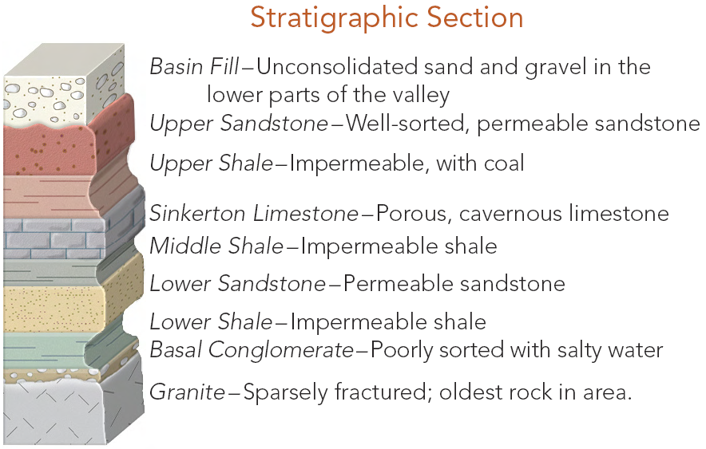
- Where does the water table have its lowest elevation, based on the wells?

a. in the eastern part of the area, near Slidetown
 b. near the ridge, west of Kellogg
 c. near Springtown
d. in the western part of the area, by Riverton

- Based on your contours of water-table elevations, what is the overall direction that groundwater flows?
- a. to the north
- b. to the east
- c. to the south
- d. to the west
- From your analysis, which facilities caused the contamination? From the list below, choose two sites that probably caused the contamination.
Note: a recent geologic study has shown that Slidetown and Springtowm are NOT sources of contamination.
a. Cornhead Coal Mine
b. Coal Power Plant
c. Midnight Coal Mine
d. CQ Coal Mine
e. Purely Plastics
f. Jim's Dairy
g. Earl's Fuel Depot
h. Walt's Farm
i. Metal Works
j. Driller's Farm
k. Birk Chemical Plant

- In which part of the area in the Investigation would you most likely find uncontaminated groundwater? Note: See the textbook graphic for a North arrow indicator.

a. north
b. east
c. south
d. west
5. Identify two or three (currently) uncontaminated wells where you would drill nearby to intercept the contamination and consequently clean up and remediate the contamination.
a. A, B, and/or C
b. E, F, and/or G, K
c. D, H
d. I, J, and/or L
e. M, N, and/or P

Table 4. Proposed Remediation Plan
In the space below, briefly summarize your conclusions about the sources of the contamination, explaining the logic you used to identify facilities that contaminated the water. Briefly summarize how you propose to stop further flow of contaminated water, specifically by drilling wells to intercept and treat the water. Justify your location of the treatment wells.

